Betty Kouadio

Professor: Dr. R Alexander

Course CMSC-204

Assignment: Assignment # 4

**Reflection**

In this Assignment#4 I learn how to manager three classes at t5he same time. Data manager data element and DataStructure.To build a basics double linked list and doubled linked list. I learn the difference between basic single linked list and ArraList .

I also learn the difference between comparable and comparator. Comparable interface has one method compareTo (obj) and the comparator interface has two methods equals(obj) and compare (obj1 , obj2)and how to override them in the DataElement. I face a difficulty to compare two same words one with the apostrophe inside a word such as user’s and user.

**Screenshot**

Example of creating a Course database from an input file

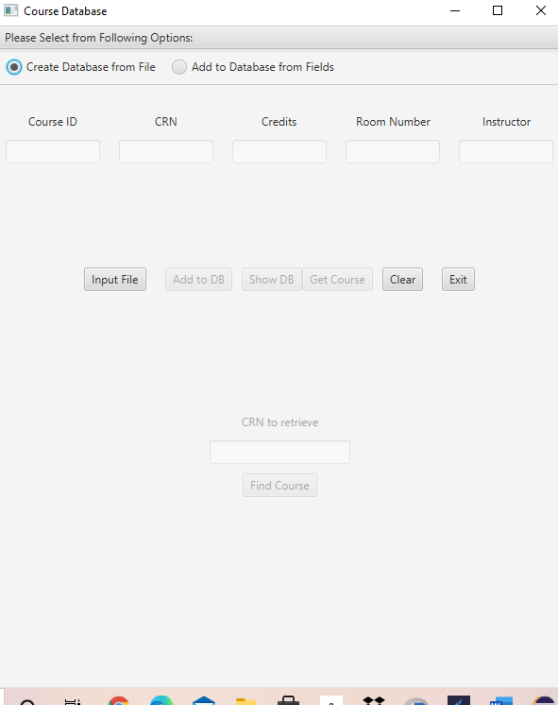

Select the input file button and navigate to the file.

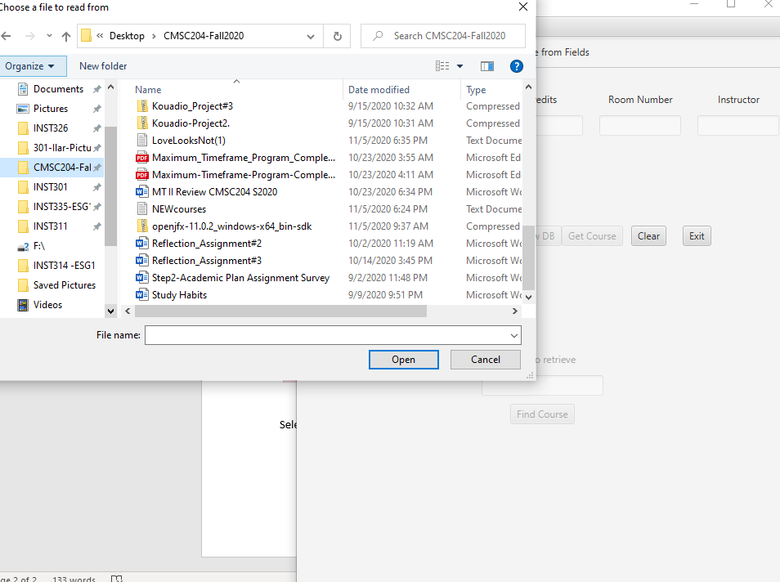

Use ShowDB button to display the CDEs that were read:

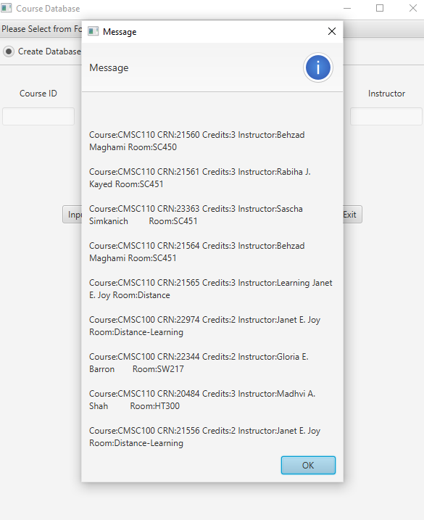

Example of Creating a CDE from text fields. First select the other radio button, then fill in the textfields, then select the “Add to DB” button.

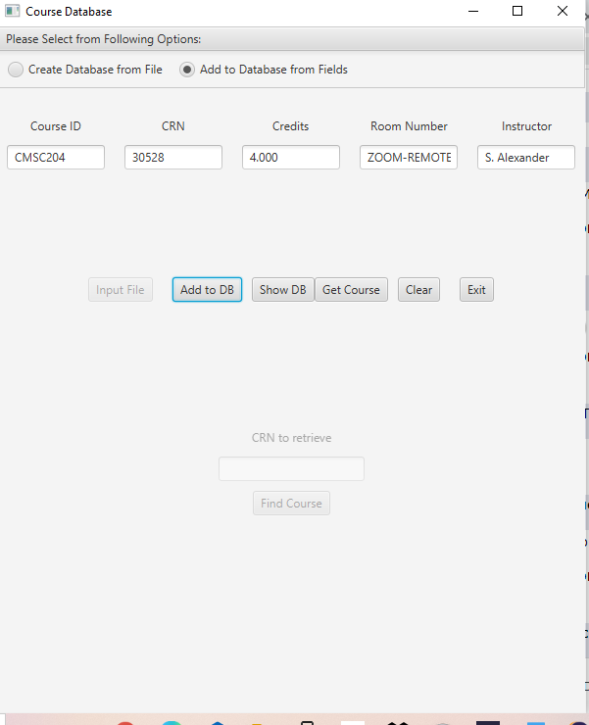

Select the Show DB button to see the resulting CDEs.

